CSS Static and Relative Positioning

Lecture 7 on intermediate CSS.

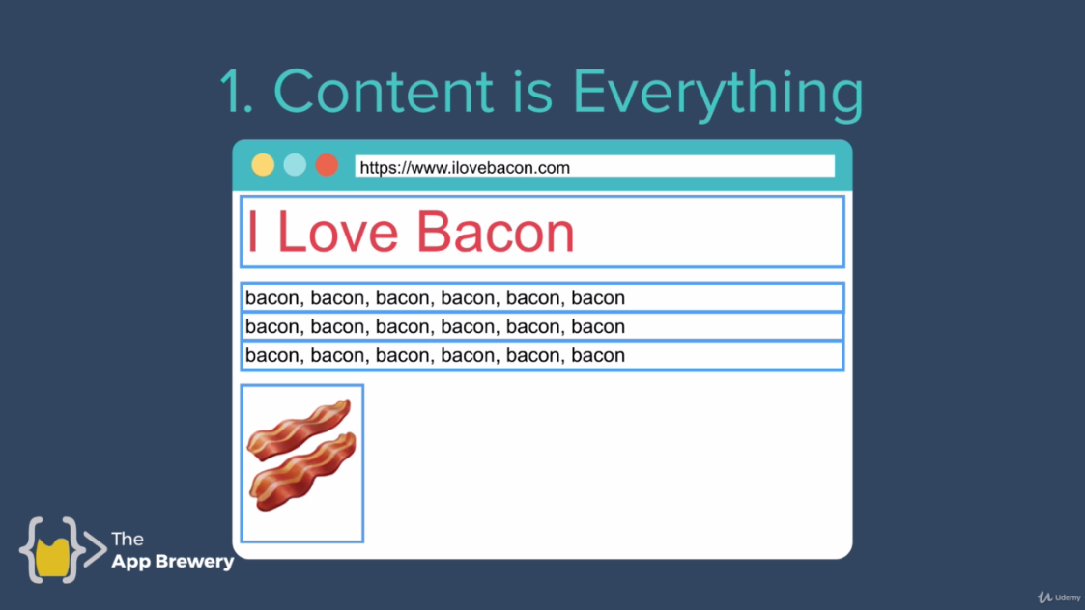

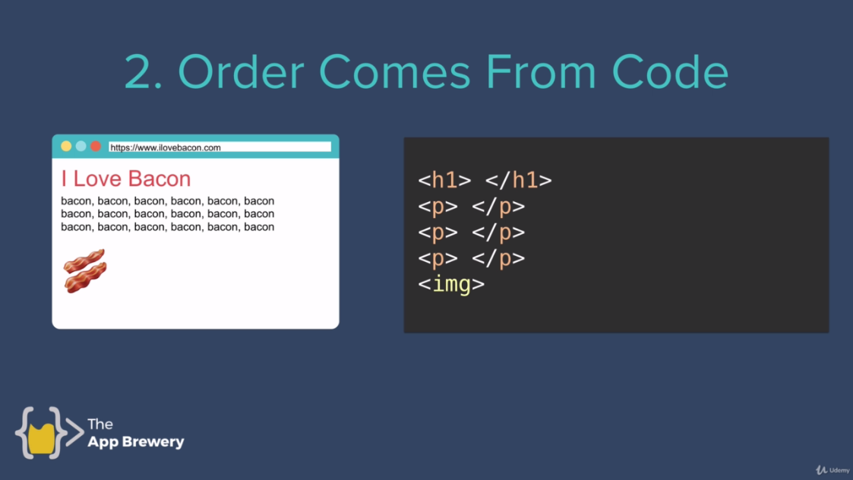

Order comes from html code.

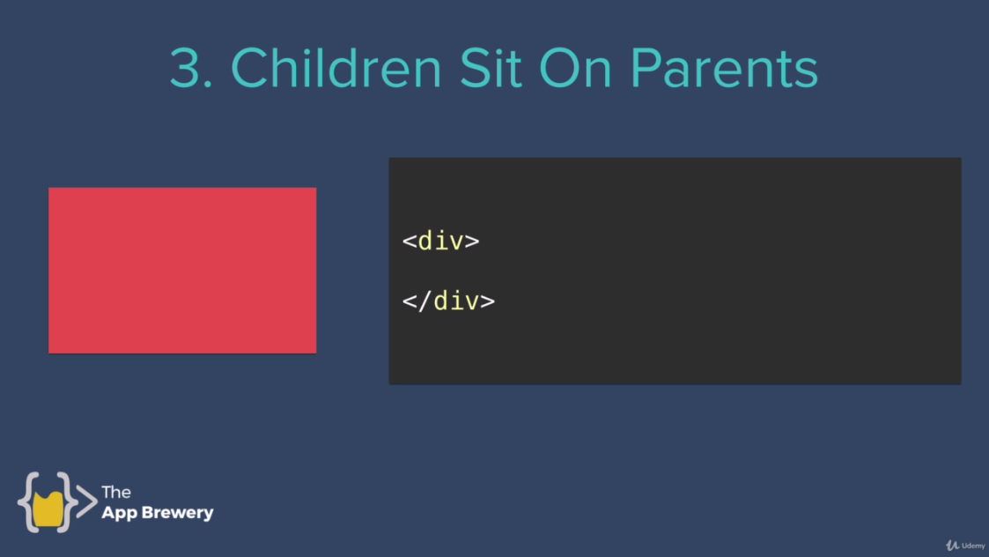

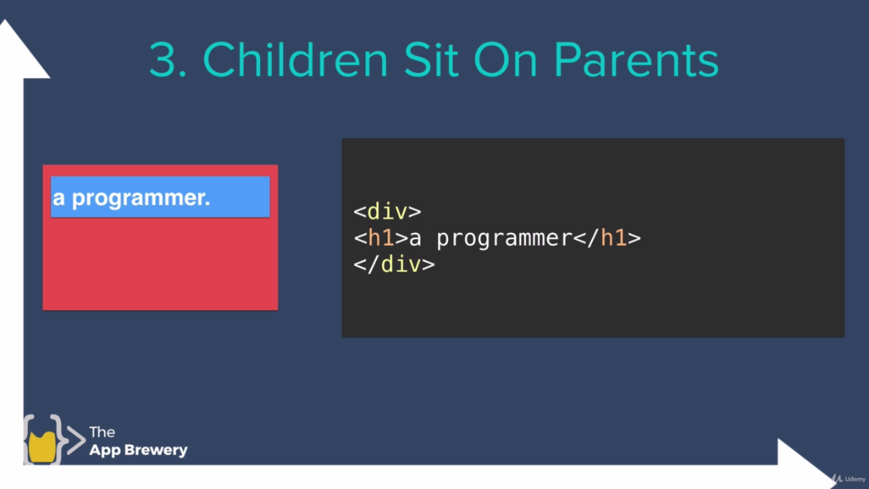

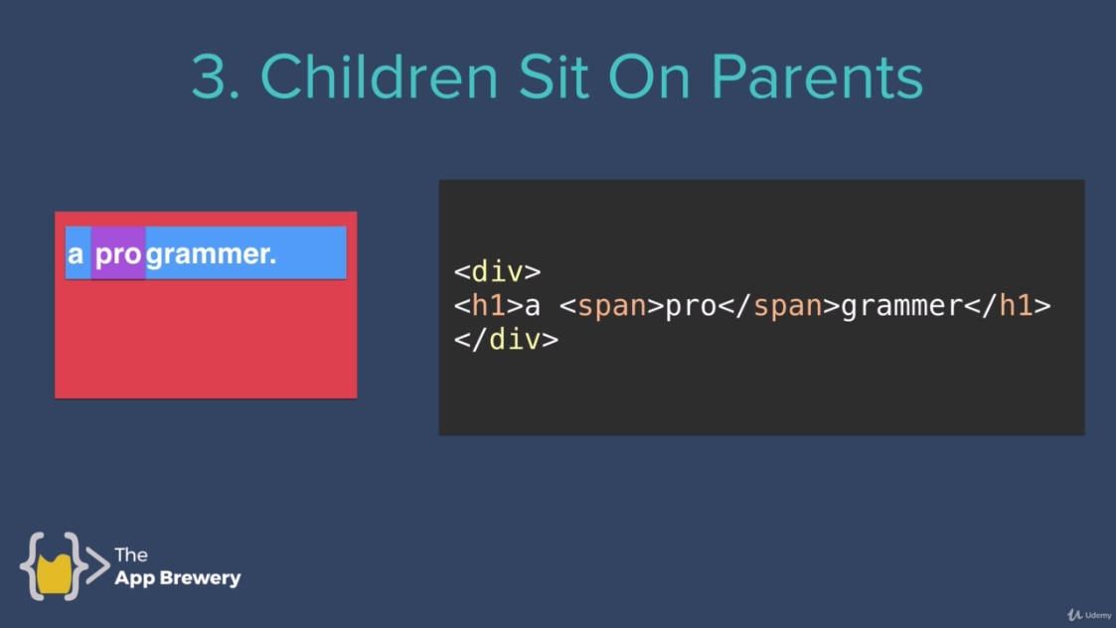

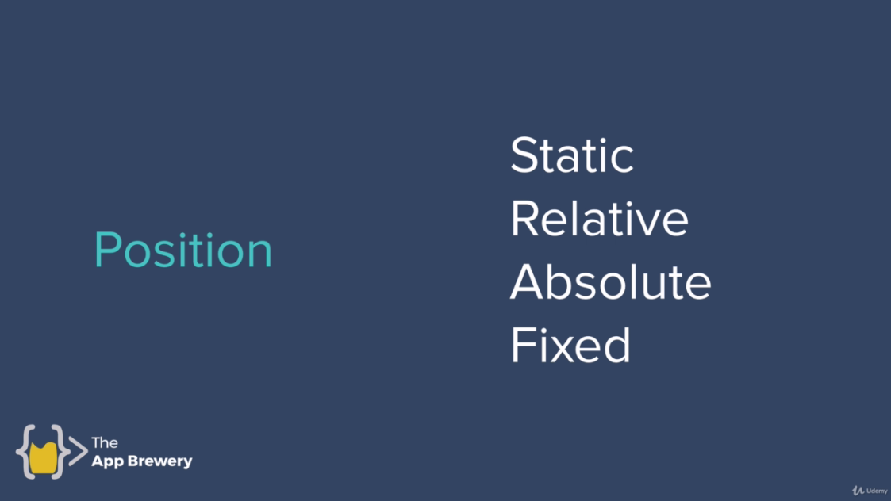

All HTML elements are static by default and we can change them according to requirement.

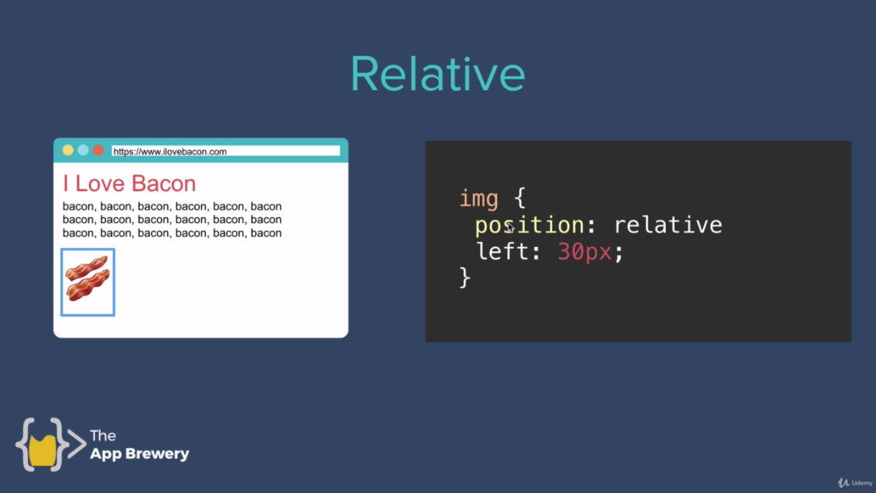

This image is by default. And the below image is when we move image from left by 30px.

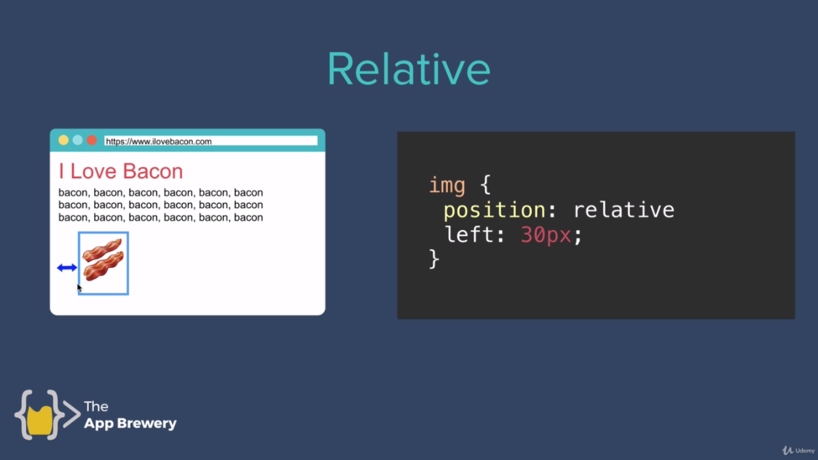



**Original Position**



Now we want to move down by 20px.



Now we want to move right by 20px.

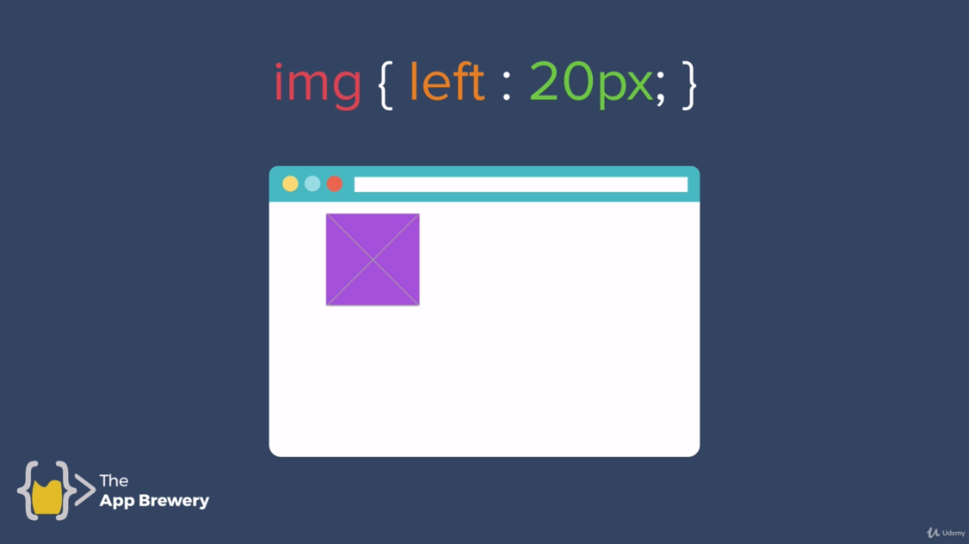

Now we want to move left by 20px.

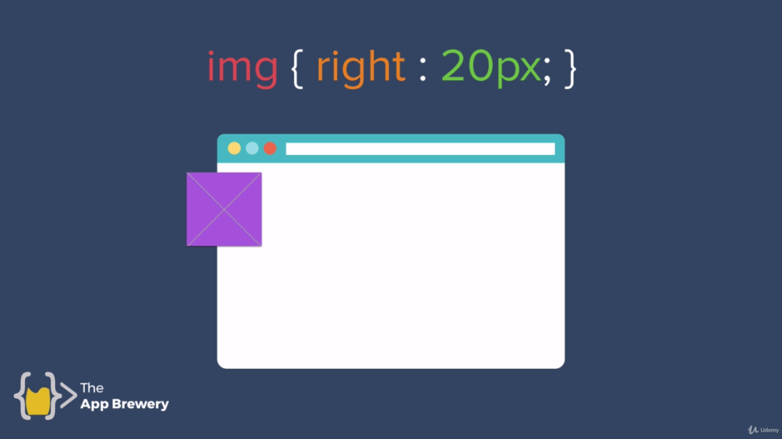

Now we want to move up by 20px.

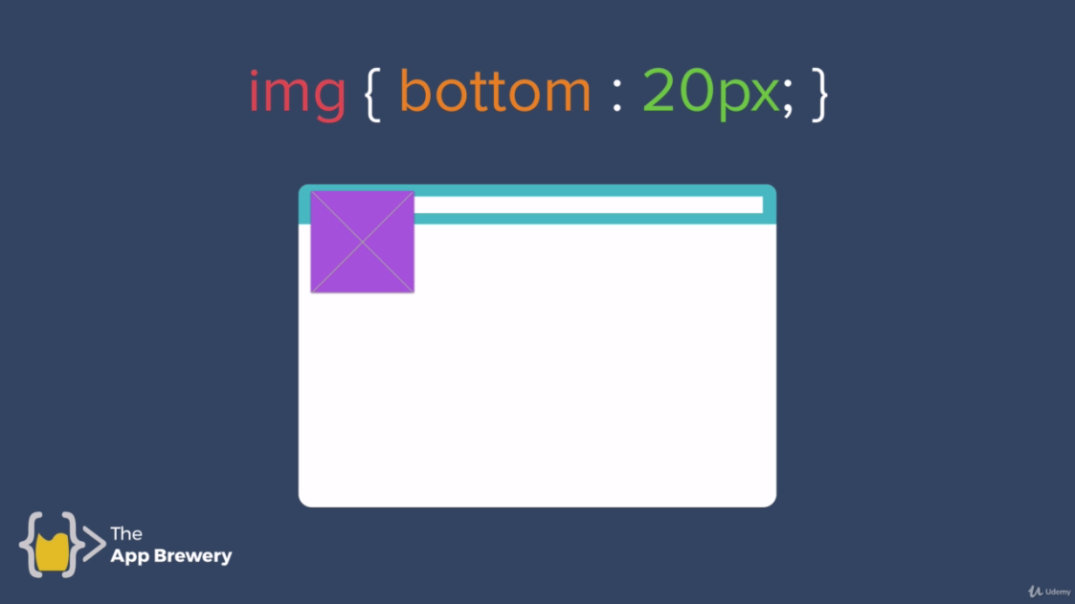

**Now when we are dealing with relative positioning.**

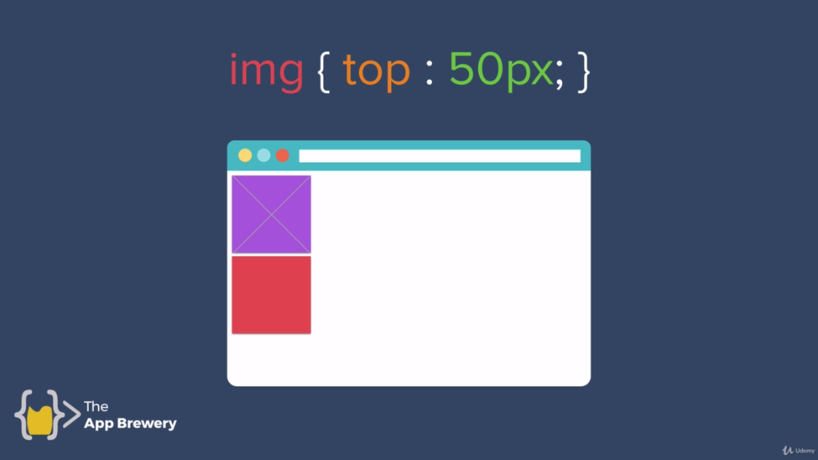

Top by 50px. It doesn’t effect on the position of anything as on screen. It’s as if all the position was gapped and everything has just flows around it.

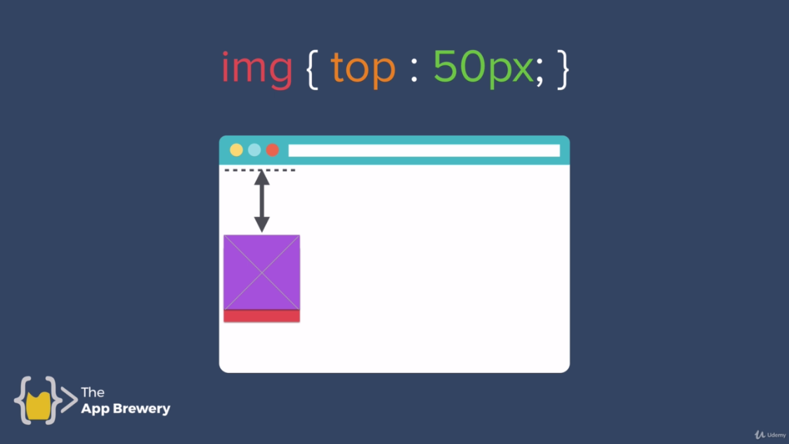

**Code:**

**Styles4.css:**

/************************* CLASS SELECTORS ***********************/

.red{

background-color: red;

height: 100px;

width: 100px;

position: relative;

/* top:50px; */

/*right:50px;*/

/* bottom: 50px;/*

/*left: 50px;*/

display: inline-block; /* to move block in line instead of top to bottom*/

}

.blue{

background-color: blue;

height: 100px;

width: 100px;

display: inline-block;

position: relative;

/* right: 30px; */

}

.yellow{

background-color: yellow;

height: 100px;

width: 100px;

display: inline-block;

}

**Index4.html:**

<!DOCTYPE html>

<html lang="en" dir="ltr">

<head>

<meta charset="utf-8">

<title>CSS Positioning</title>

<link rel="stylesheet" href="css/styles4.css">

</head>

<body>

<h1>CSS Static and Relative Positioning</h1>

<div class="red">

</div>

<div class="blue">

</div>

<div class="yellow">

</div>

</body>

</html>